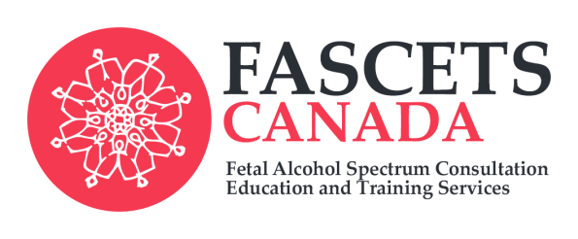
Based on the acclaimed work of
FASD expert and published
Author, Diane Malbin, MSW…
Demystifying FASD and
other Neurobehavioural
Conditions

Registration Form
Special Three Day Training for Parents and Professionals
October 17th, 18th and 19th, 2016
Westmount Event Centre
227 Bowes Road, Vaughan, ON, L4K 1H8
Follow this link for location information: https://www.google.ca/maps/dir/''/westmount+event+centre/@43.8082786,79.5620398,12z/data=!3m1!4b1!4m8!4m7!1m0!1m5!1m1!1s0x882b2e8cdbcb63d1:0xb666545019118718!2m2!1d-79.492!2d43.8083

Name: __________________________________________________________________
Address: ________________________________________________________________
Email Address: ___________________________________________________________
Telephone Number: _______________________________________________________
Agency: (where applicable) _________________________________________________
To register please complete this form and send with $300+ HST cash or cheque to:
FASCETS Canada East
1644 Curly Lane
Ottawa, ON, K4P 0B9
*Cheques to be made payable to ‘FASCETS Canada East’
*To register and pay by credit card please contact trishfascetscanadaeast@gmail.com
*Space is limited. Registration closes October 11th, 2016
*For more information contact trishfascetscanadaeast@gmail.com or go to www.fascetscanada.com

